

**YOGA CENTER**

**Software Requirement Specification**

– HCM, May 2023 –

**Table of Contents**

I. Overview 3

1. Introduction 3

2. System Functions 4

3. Common Requirements 7

II. Functional Requirements 8

1. Public Feature 8

a. Home Page 8

b. Courses List 8

c. View course 9

c. View package 10

d. View schedule 10

2. Common Feature 11

a. Login 11

b. Login with Google 12

c. Register 13

d. Recovery Password 14

e. Get Account Profile 15

f. Update Account Profile 16

g. Change Password 17

3. Customer Feature 19

a. Checkout 19

b. Payment 20

4. Staff Feature 20

a. Semester Management 20

b. Course Management 23

c. Class Management 27

d. Schedule Management 29

e. Membership Management 32

f. Package Management 34

5. Admin Feature 36

a. Account Management 36

b. Admin Dashboard 37

# I. Overview

## 1. Introduction

Heartbeat is a helpful website that can help users to manage information & service, schedule, class, course, package, semester and membership.

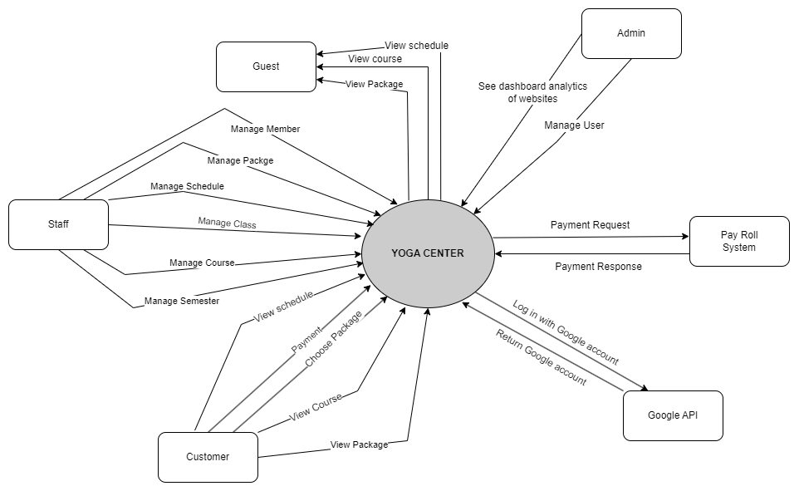

## 2. System Functions

#### a. Screen Flow

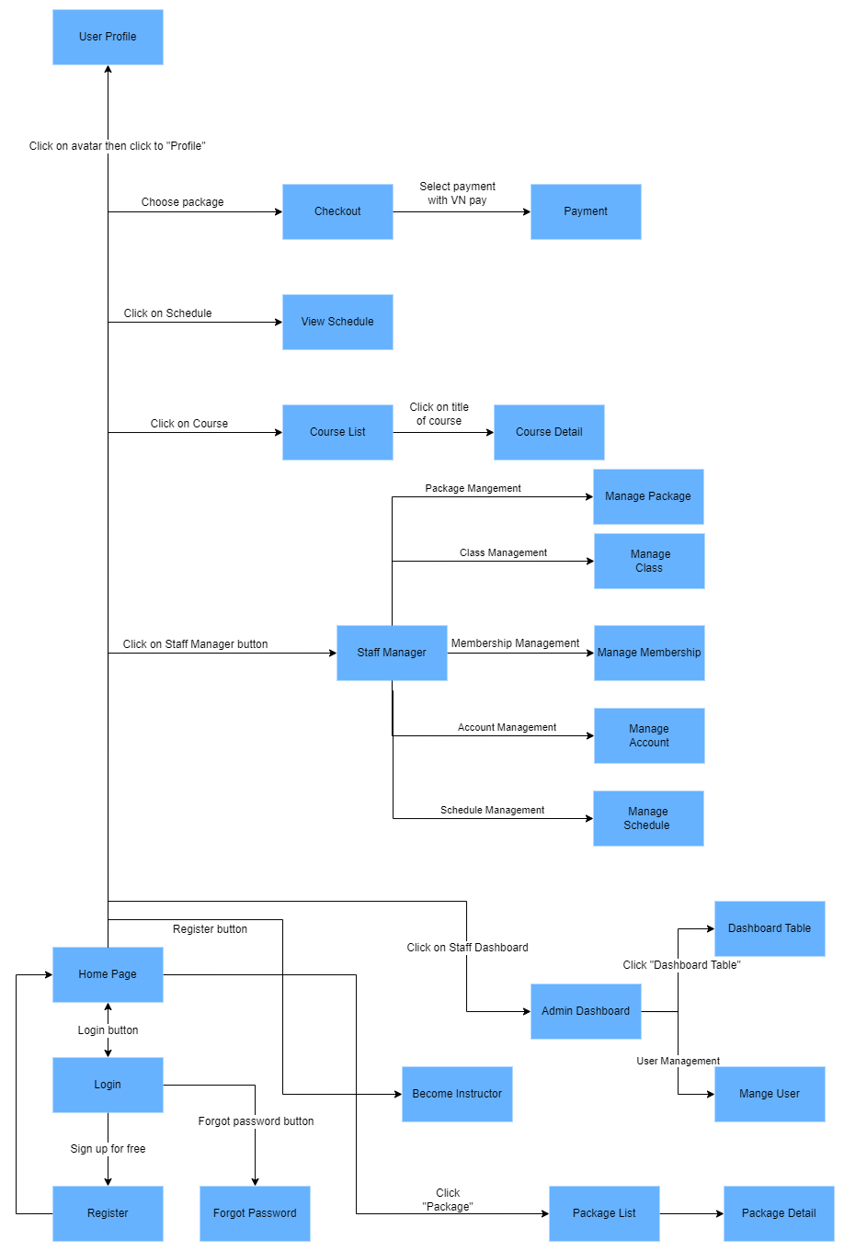

#### b. Screen Details

| **#** | **Feature** | **Screen** | **Description** |
| --- | --- | --- | --- |
|  | Public | Home Page | The starting page of the system |
|  | Public | View courses list | Allow users to view a list of courses |
|  | Public | View course | Allow users to view details of the course. |
|  | Public | View Schedule | Allow users to view schedule |
|  | Public | View Package | Allow users to view packages |
|  | Common | Login | User can log in to the system with the system account |
|  | Common | Login with Google | Users can log in to the system with the Google account |
|  | Common | Register | This page is only for users who want to create an account to log in to the system. |
|  | Common | Recovery Password | This feature will send a new password to their email address if the email is verified. |
|  |  |  |  |
|  | Common | Get Account Profile | shows general information about the account like date of birth, country, region, phone number, email address, and username. |
|  | Common | Update Profile | Users can edit information about accounts like username, dob, and phone number, ... |
|  | Common | Change Password | Change password is a feature when users want to change a new password for their account. |
|  | Customer | Checkout | Allow user to checkout |
|  | Customer | Payment | Allow user to payment |
|  | Staff | Staff Manager | Show all the tasks which staff can manage |
|  | Staff | Package Management | Staff can manage packages. |
|  | Staff | Schedule Management | Staff can manage schedules. |
|  | Staff | Course Management | Staff can manage courses, |
|  | Staff | Semester Management | Staff can manage semesters |
|  | Staff | Class Management | Staff can manage classes. |
|  | Staff | Membership  management | Staff can manage semester |
|  | Admin | User Management | Admin can manage user. |
|  | Admin | Admin Dashboard | Allows the admin to see all the information of the web application. |

#### c. User Authorization

| **Screen** | **Guest** | **Customer** | **Staff** | **Admin** |
| --- | --- | --- | --- | --- |
| <<Screen Login>> | X | X | X | X |
| Login with system account | X | X | X | X |
| Login with Google account | X | X | X | X |
|  |  |  |  |  |
| <<Screen Register>> | X | X | X | X |
| Register account | X | X | X | X |
|  |  |  |  |  |
| <<Screen Checkout>> |  | X |  |  |
| Checkout |  | X |  |  |
|  |  |  |  |  |
| <<Screen Payment>> |  | X |  |  |
| Payment |  | X |  |  |
|  |  |  |  |  |
| <<Reset Password>> |  |  |  |  |
| Forgot Password | X | X | X | X |
|  |  |  |  |  |
| <<Screen Home>> | X | X | X | X |
| Home Page | X | X | X | X |
| Search Class | X | X | X | X |
| Course List | X | X | X | X |
| Favourite course | X | X | X | X |
|  |  |  |  |  |
| <<Screen Account Profile>> |  | X | X | X |
| Account Profile |  | X | X | X |
| Update Profile |  | X | X | X |
|  |  |  |  |  |
| <<Screen Course Detail>> | X | X | X | X |
| Course Details | X | X | X | X |
|  |  |  |  |  |
| <<Screen Staff>> |  |  | X |  |
| Semester management |  |  | X |  |
| Course management |  |  | X |  |
| Class management |  |  | X |  |
| Schedule management |  |  | X |  |
| Member management |  |  | X |  |
|  |  |  |  |  |
| <<Screen Admin>> |  |  |  | X |
| Admin dashboard |  |  |  | X |
| User management |  |  |  | X |

#### d. Non-Screen Functions

| **#** | **Feature** | **System Function** | **Description** |
| --- | --- | --- | --- |
| 1 | Common | userAuthorization | Check the user if they are allowed to enter the class or not. |
| 2 | Common | encodeSHA256 | Encode the password with SHA-256 to secure the password. |
| 3 | Common | sign-out | Users sign out of the system |
| 4 | Common | input validation | Valid user’s input. |

## 3. Common Requirements

* The system must display courses, packages, and schedules for users.
* The system must be easy to use for all non-technical users, specifically for the Staff only needing 1 day to use all the main features without training.
* The user can check out and payment with VNpay or in the center.
* The Admin must be able to ban another user.
* The system must update the user to become a member right away after their payment at VNPay.
* The system must send an email notification to the user when they are on the deadline for the membership.

# II. Functional Requirements

## 1. Public Feature

### a. Home Page

* Function trigger: This function is triggered when the user visits the website or the system homepage
* Function description: The User sees briefs about the introduction, course list, and video,
* Screen layout: simulated prototype of the screen, the sample below is for the home screen

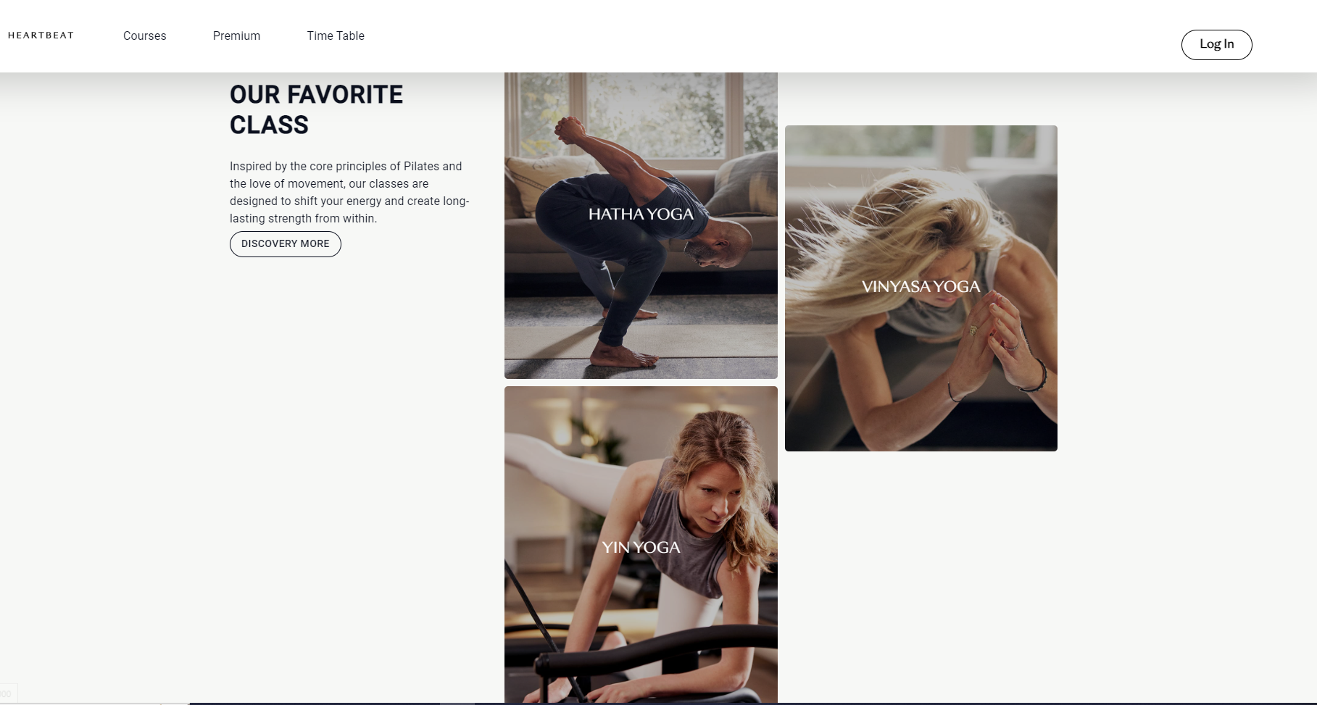

* Function Details: When the user access the system, the homepage will appear and show information about the system

### b. Courses List

* Function trigger: This function is triggered when the user visits the website or the system course list
* Function description: The user sees the list of courses.
* Screen layout: simulated prototype of the screen, the sample below is for the courses list screen



* Function Details: When the user clicks on courses, the systems will display all the courses available.

### c. View course

* Function trigger: This function is triggered when the user visits the website or the system to view the course.
* Function description: The user sees the course information.
* Screen layout: simulated prototype of the screen, the sample below is for the course screen

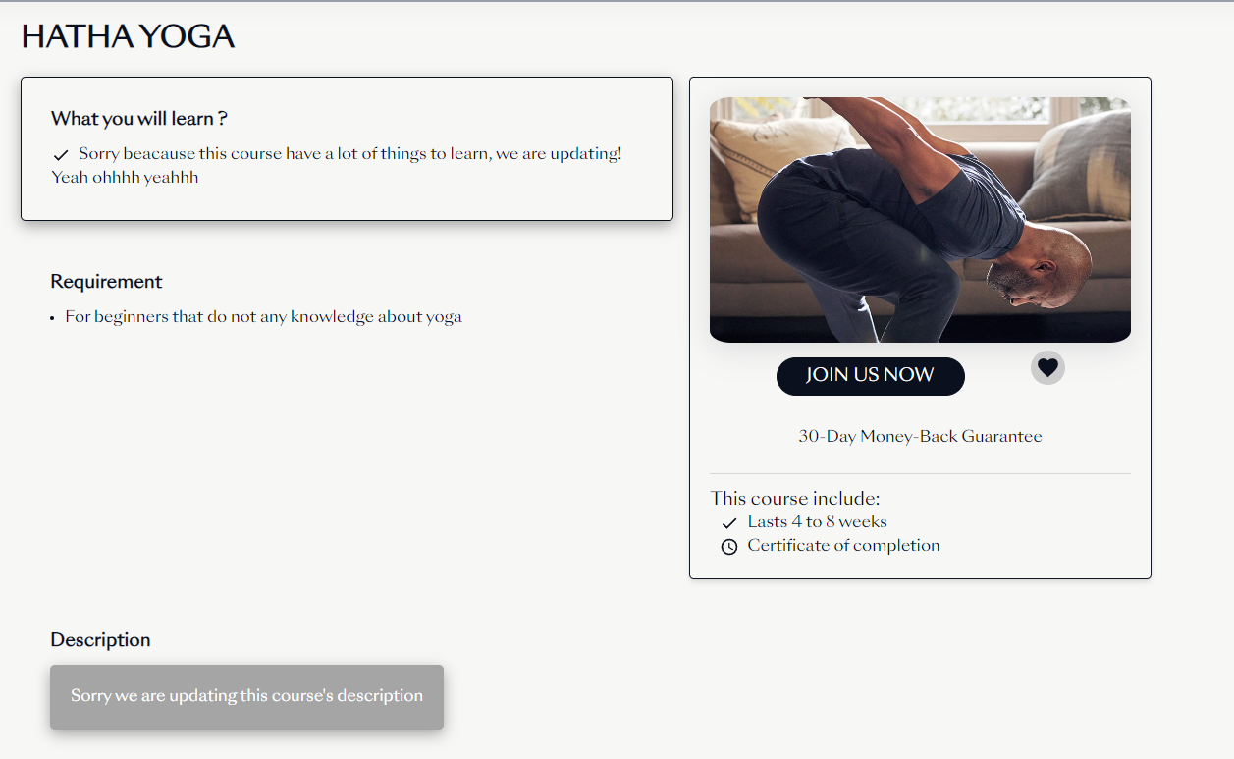

* Function Details: When the user clicks on one of the specific courses, this page will show all the information about the course selected.

### c. View package

* Function trigger: This function is triggered when the user visits the website or the system to view the package.
* Function description: The user sees the package information.
* Screen layout: simulated prototype of the screen, the sample below is for the package screen

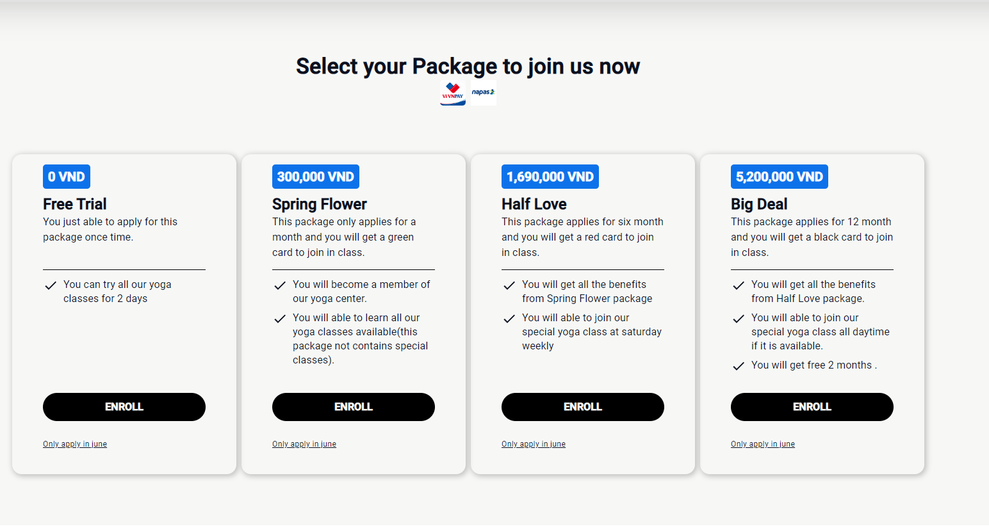

* Function Details: When the user clicks on the package button, this page will show all the information about the package.

### d. View schedule

* Function trigger: This function is triggered when the user visits the website or the system to view the package.
* Function description: The user sees the schedule information.
* Screen layout: simulated prototype of the screen, the sample below is for the package screen

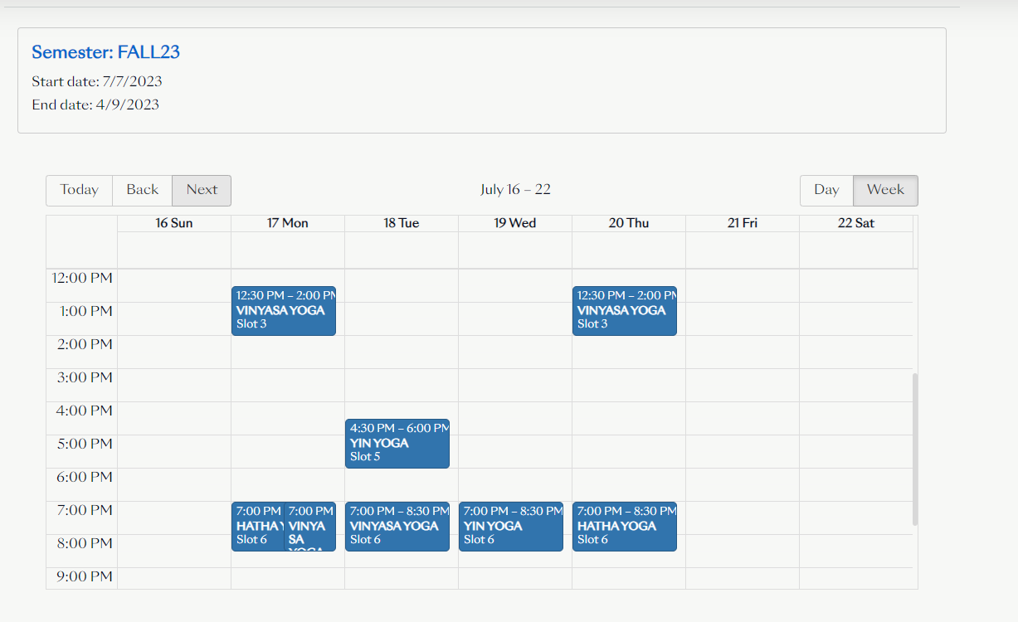

* Function Details: When the user clicks on the schedule button, this page will show all the information about the schedule.

## 2. Common Feature

### a. Login

* Function trigger: This function is triggered when the user visits the website or the system to log in.
* Function description: The user sees the log-in screen.
* Screen layout: simulated prototype of the screen, the sample below is for the login screen

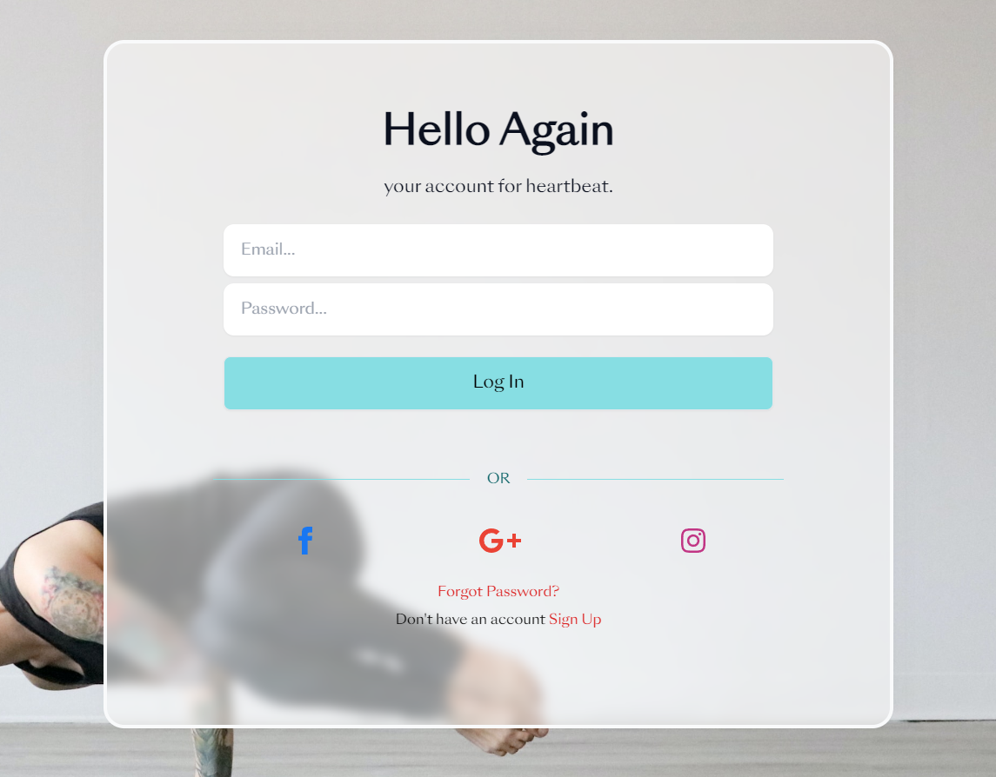

* Function Details: When the user clicks on the login button, this page displays the form to log in.

### b. Login with Google

* Function trigger: This function is triggered when the user visits the website or the system to log in with Google.
* Function description: The user sees the log-in screen.
* Screen layout: simulated prototype of the screen, the sample below is for the login screen

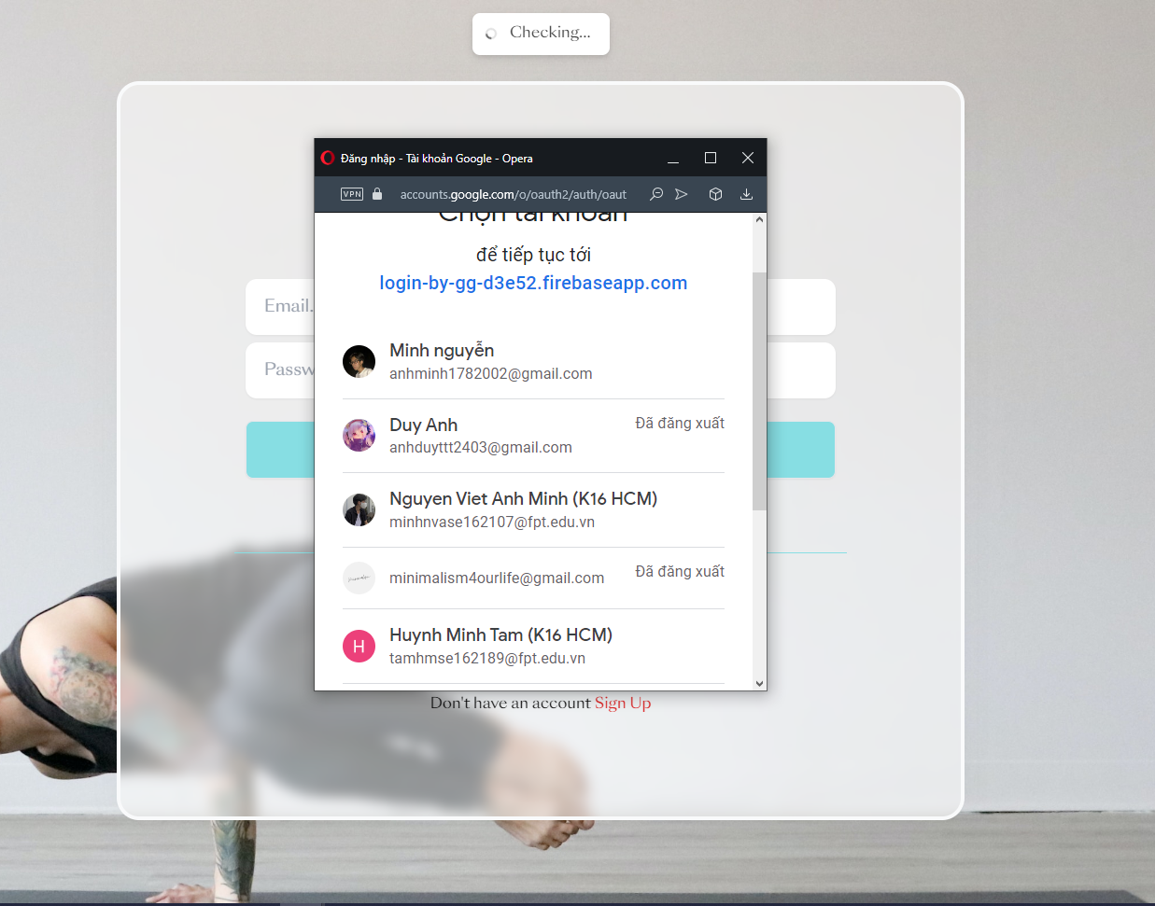

* Function Details: When the user clicks the login button, this page displays the form to log in with a Google account.

### c. Register

* Function trigger: This function is triggered when the user visits the website or the system to register.
* Function description: The user sees the register screen.
* Screen layout: simulated prototype of the screen, the sample below is for the register screen

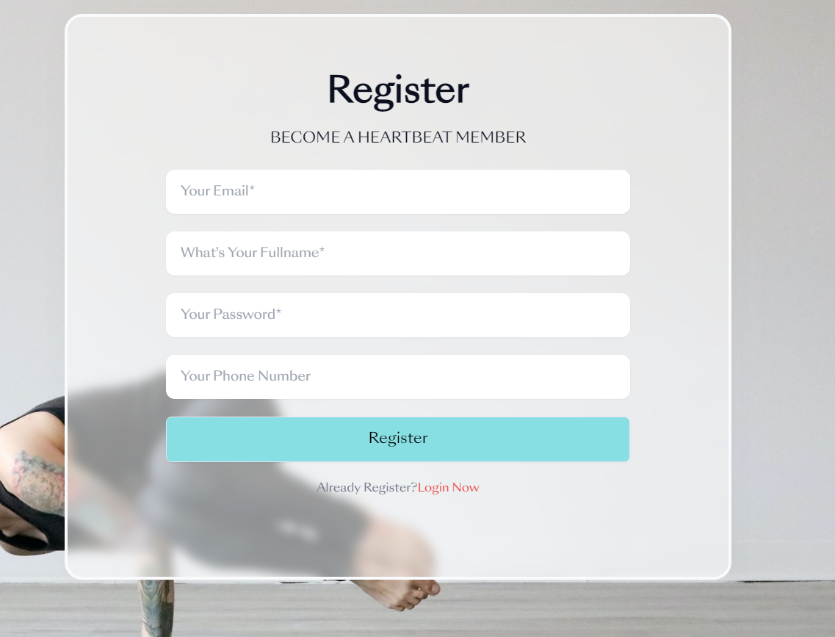

* Function Details: When the user clicks the register button, this page displays the form to register an account.

### d. Recovery Password

* Function trigger: This function is triggered when the user visits the website or the system to recover the password.
* Function description: The user sees the recovery password screen.
* Screen layout: simulated prototype of the screen, the sample below is for the recovery password screen

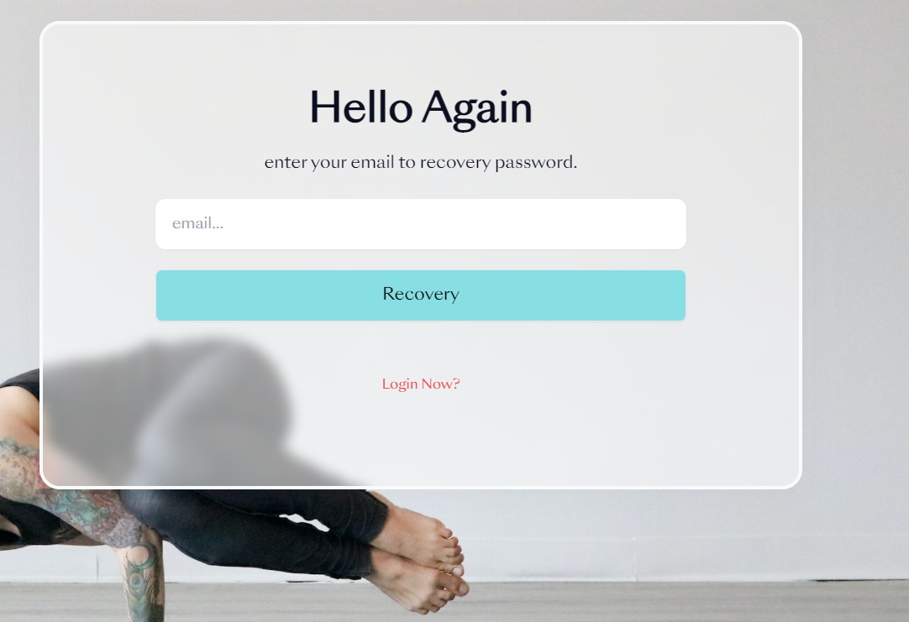

* Function Details: When the user clicks the forgot password button, this page displays the form to recover the password.

### e. Get Account Profile

* Function trigger: This function is triggered when the user visits the website or the system to Get an Account Profile.
* Function description: The user sees the Account Profile screen.
* Screen layout: simulated prototype of the screen, the sample below is for the Account Profile screen.

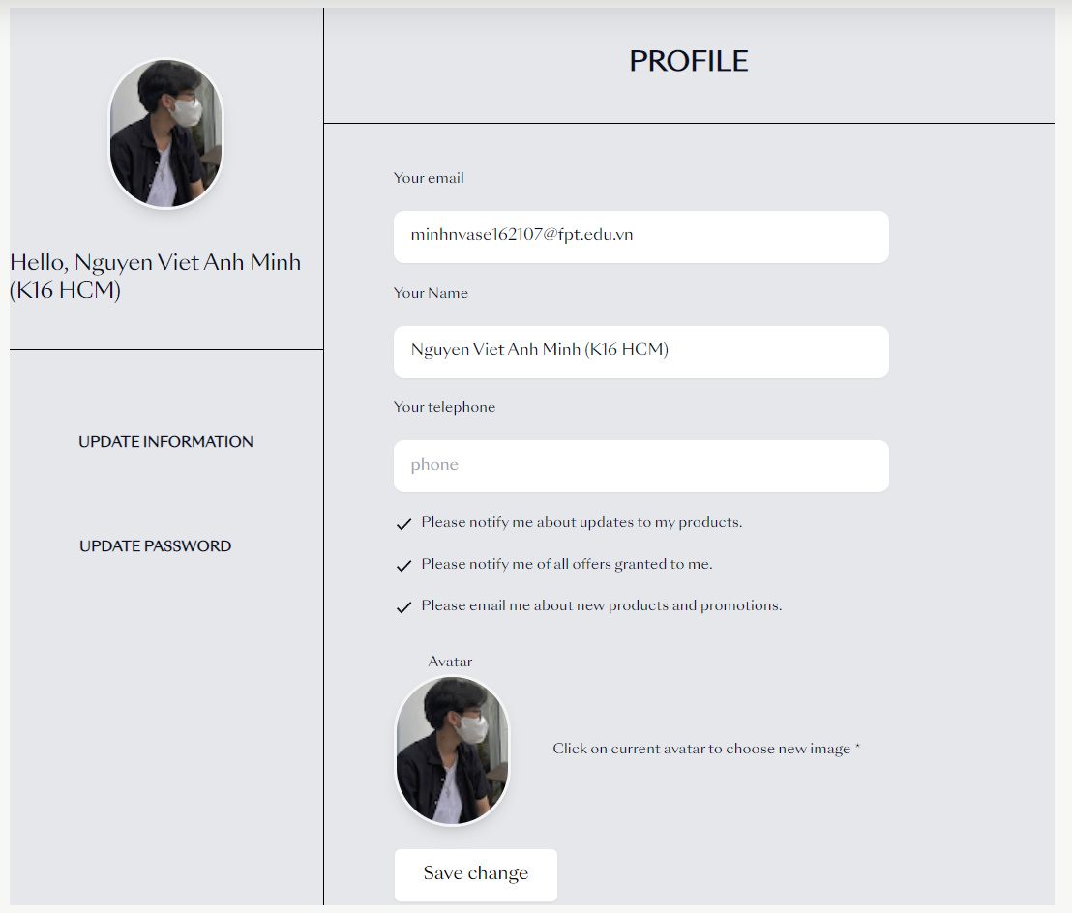

* Function Details: When the user clicks on the account button, this page displays the information about the user’s account.

### f. Update Account Profile

* Function trigger: This function is triggered when the user visits the website or the system to Update an Account Profile.
* Function description: The user sees the Account Profile screen.
* Screen layout: simulated prototype of the screen, the sample below is for the Account Profile screen.

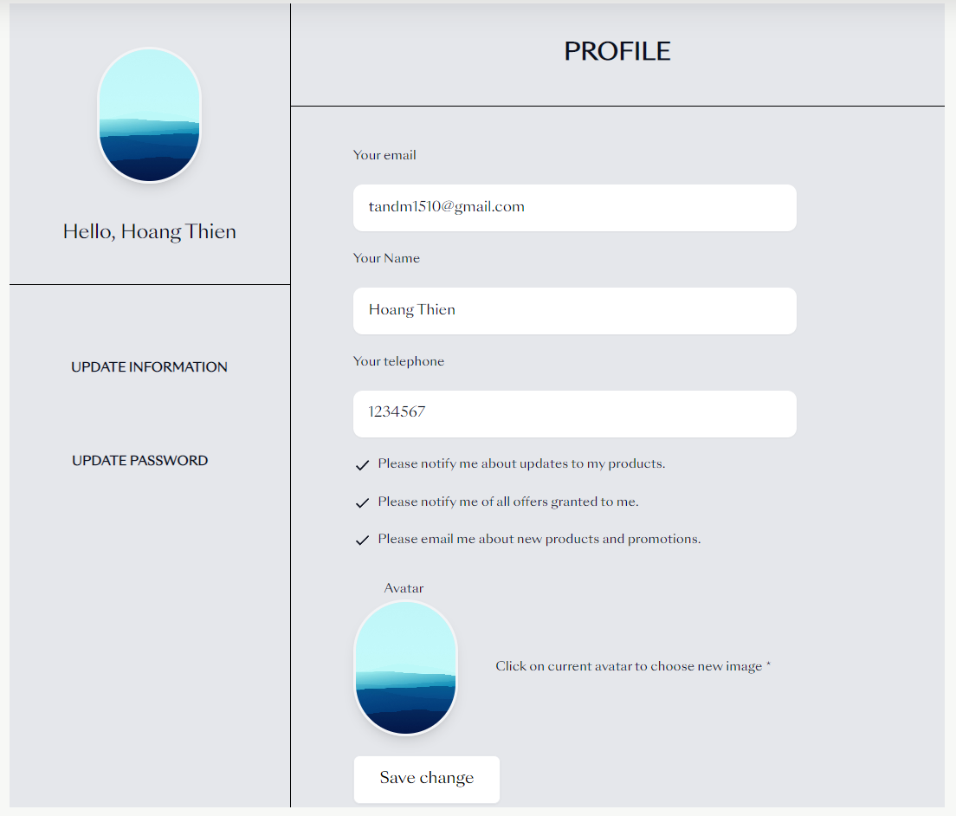

* Function Details: When the user clicks on the save change button, the user can update their news information.

### g. Change Password

* Function trigger: This function is triggered when the user visits the website or the system to Change the password.
* Function description: The user sees the Reset password screen.
* Screen layout: simulated prototype of the screen, the sample below is for the Change password screen.

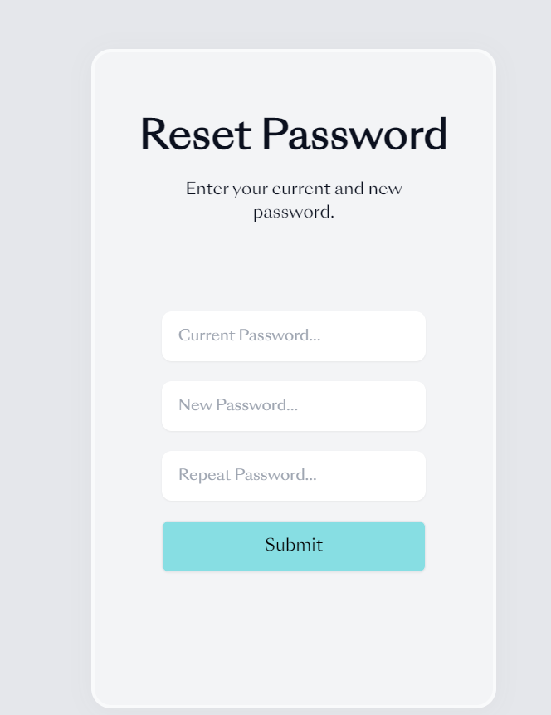

* Function Details: When the user clicks on the change password button, this page displays the form to change the password.

## 3. Customer Feature

### a. Checkout

* Function trigger: This function is triggered when the user visits the website or the system to check out.
* Function description: The user sees the checkout screen.
* Screen layout: simulated screen prototype, the sample below is for the Checkout screen.

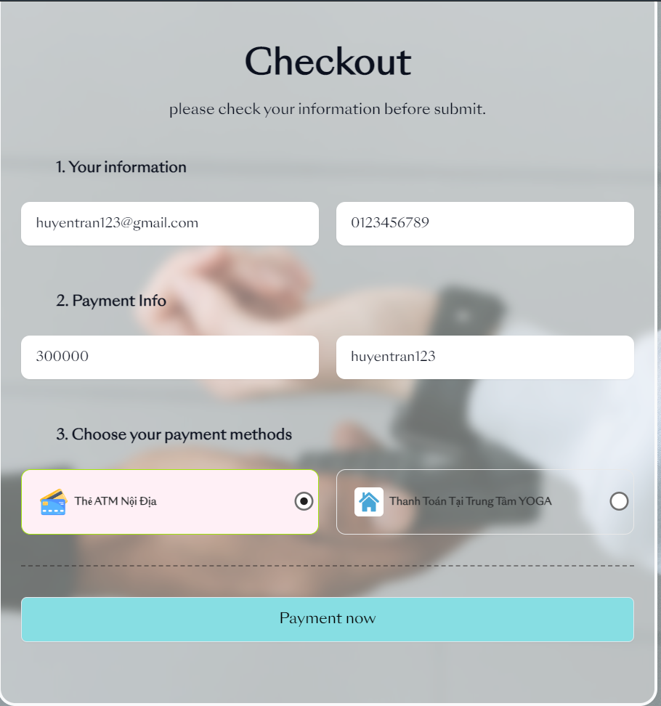

* Function Details: When the user clicks on the checkout button, this page displays the form to checkout.

### b. Payment

* Function trigger: This function is triggered when the user visits the website or the system to Payment.
* Function description: The user sees the Payment screen.
* Screen layout: simulated prototype of the screen, the sample below is for the Payment screen.

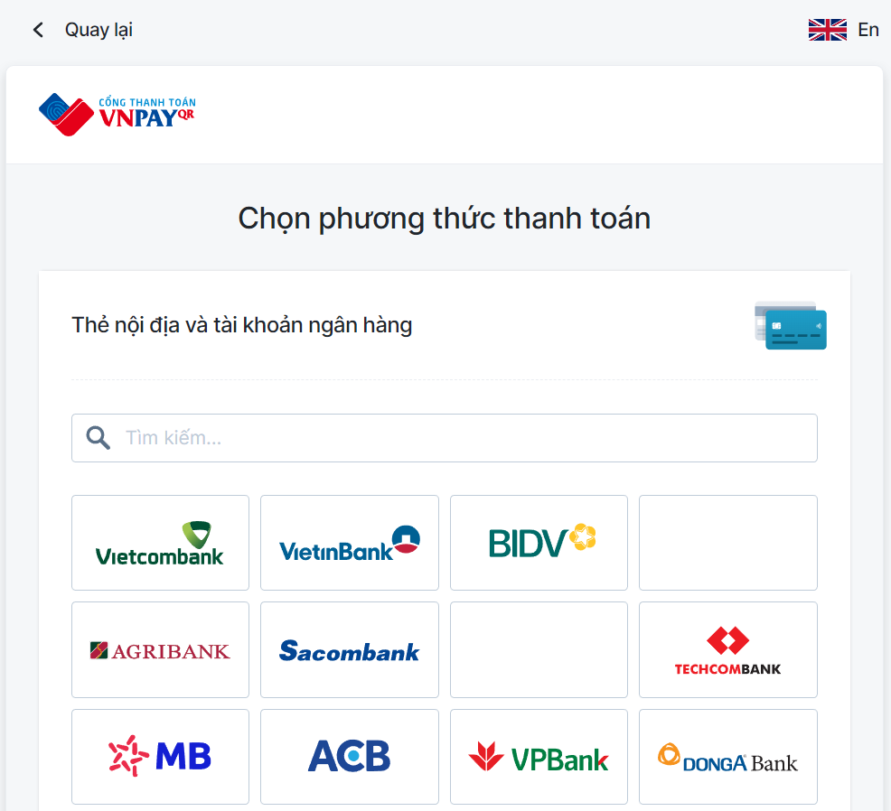

* Function Details: When the user clicks on the payment button, this page displays the form for payment.

## 4. Staff Feature

### a. Semester Management

#### a.1) View Semester List

* Function trigger: This function is triggered when the user visits the website or the system to view the semester list.
* Function description: Th user sees the Manage Semester screen.
* Screen layout: simulated screen prototype, the sample below is for the Manage Semester screen.

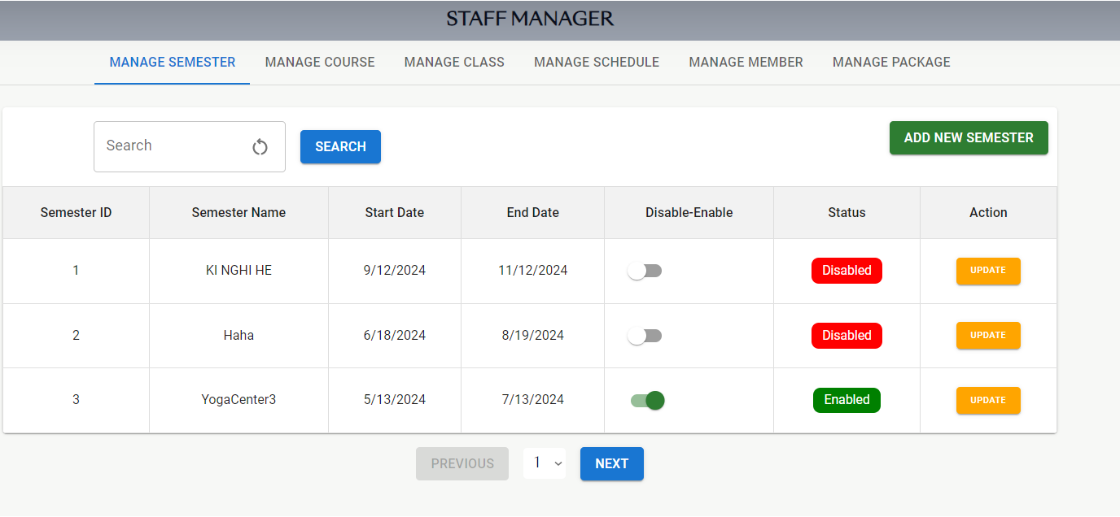

* Function Details: When the user sends the request to get the semester list, this page displays the form for viewing the semester.

#### a.2) Add Semester

* Function trigger: This function is triggered when the user visits the website or the system to add the semester.
* Function description: The user see the Add New Semester screen.
* Screen layout: simulated screen prototype, the sample below is for the Add New Semester.

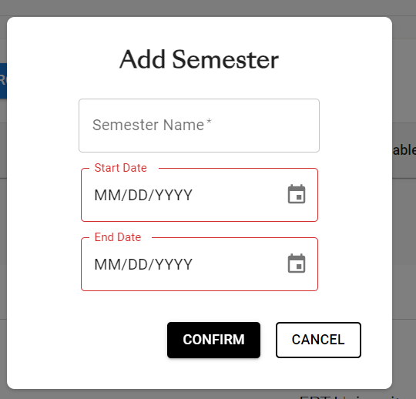

* Function Details: When the user clicks the “Add” button, this page displays the form for adding a new semester.

#### a.3) Update Semester

* Function trigger: This function is triggered when the user visits the website or the system to edit the semester.
* Function description: The user sees the Update Semester screen.
* Screen layout: simulated screen prototype, the sample below is for the Update Semester screen.

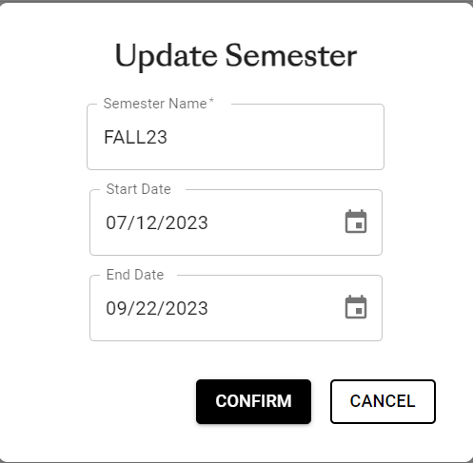

* Function Details: When the user clicks the “Update” button, this page displays the form for updating the semester.

#### a.4) Search Semester

* Function trigger: This function is triggered when the user visits the website or the system to search the semester.
* Function description: The user sees the Manage Semester screen.
* Screen layout: simulated screen prototype, the sample below is for the Manage Semester screen.

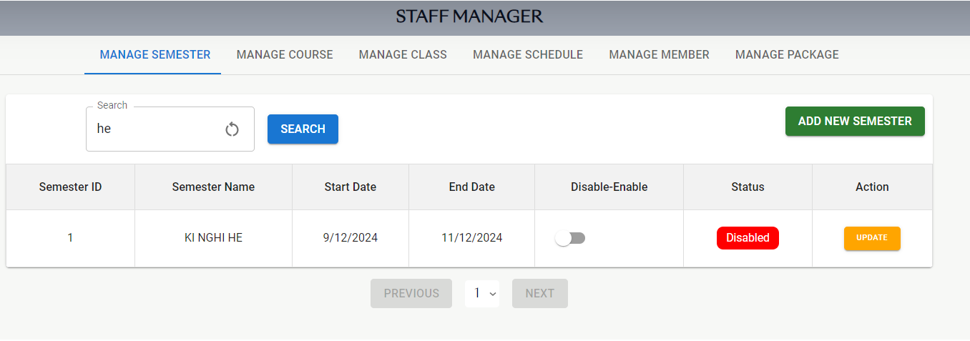

* Function Details: When the user clicks the “Search” button, this page displays the form for searching the semester.

### b. Course Management

#### b.1) View Course List

* Function trigger: This function is triggered when the user visits the website or the system to view the course list.
* Function description: The user sees the Manage Course screen.
* Screen layout: simulated screen prototype, the sample below is for the Manage Course screen.

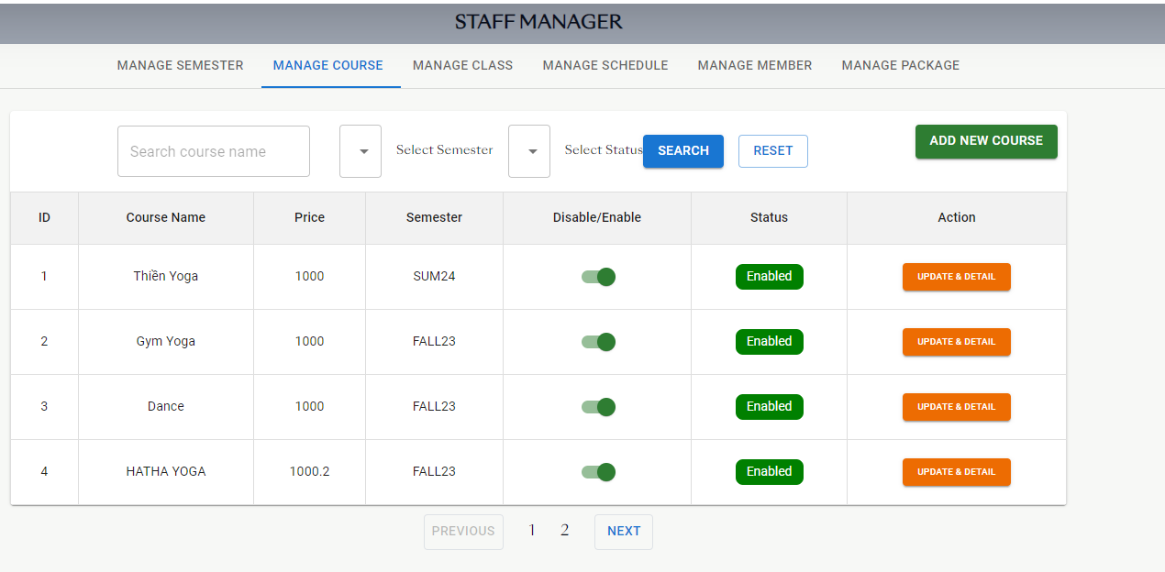

* Function Details: When the user sends the request to get the course list, this page displays the form for viewing the course list.

#### b.2) Add Course

* Function trigger: This function is triggered when the user visits the website or the system to add the course.
* Function description: The user sees the Add New Course screen.
* Screen layout: simulated prototype of the screen, the sample below is for the Add New Course.

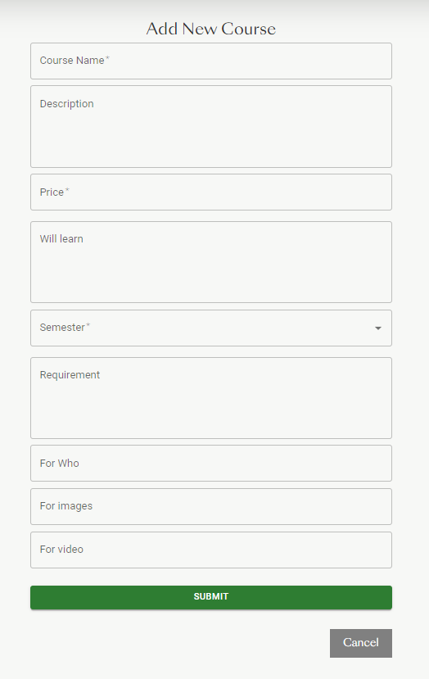

* Function Details: When the user clicks the “Add” button, this page displays the form for adding a new course.

#### b.3) Update Course

* Function trigger: This function is triggered when the user visits the website or the system to edit the course.
* Function description: The user sees the Update Course screen.
* Screen layout: simulated prototype of the screen, the sample below is for the Update Course screen.

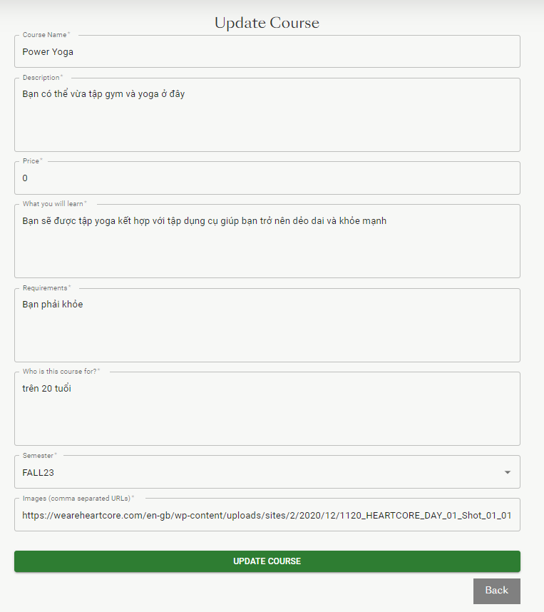

* Function Details: When the user clicks the “Update” button, this page displays the form for updating the course.

#### b.4) Search Course

* Function trigger: This function is triggered when the user visits the website or the system to search the course.
* Function description: The user sees the Update Course screen.
* Screen layout: simulated screen prototype, the sample below is for the Manage Course screen.

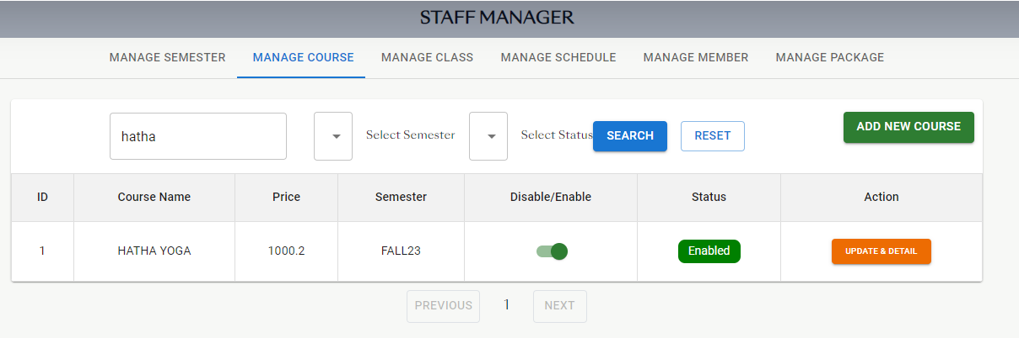

* Function Details: When the user clicks the “Search” button, this page displays the form for searching the course.

#### b.5) Filter Course

* Function trigger: This function is triggered when the user visits the website or the system to filter the course.
* Function description: The user sees the Filter Course screen.
* Screen layout: simulated screen prototype, the sample below is for the Manage Course screen.

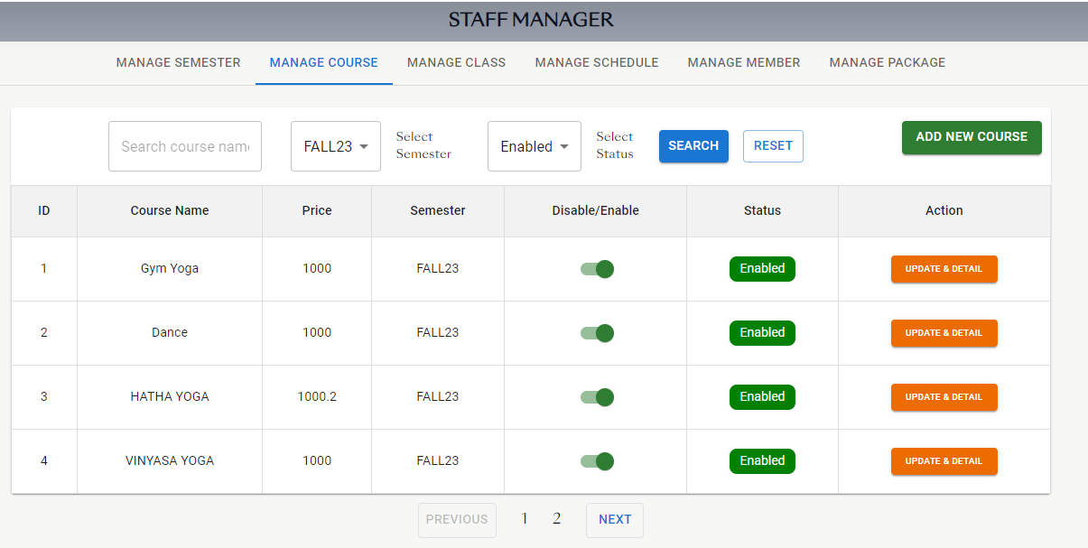

* Function Details: When the user sends the request to filter the course, this page displays the form for filtering the course.

### c. Class Management

#### c.1) View Class List

* Function trigger: This function is triggered when the user visits the website or the system to view the class list.
* Function description: The user sees the Manage Class screen.
* Screen layout: simulated screen prototype, the sample below is for the Manage Class screen.

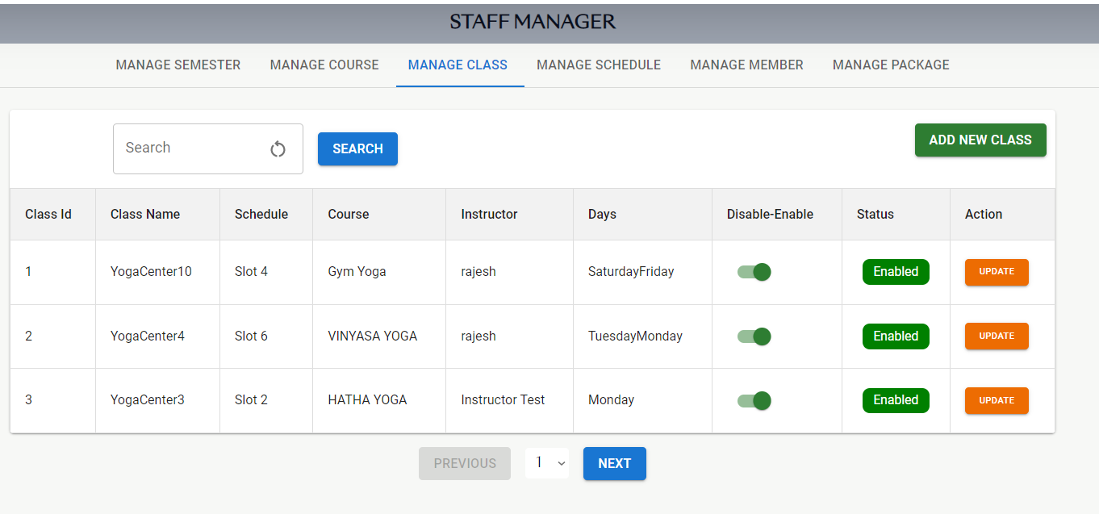

* Function Details: When the user sends the request to get the class list, this page displays the form for viewing the class list.

#### c.2) Add Class

* Function trigger: This function is triggered when the user visits the website or the system to add the class.
* Function description: The user sees the Add Class screen.
* Screen layout: simulated prototype of the screen, the sample below is for the Add Class screen.

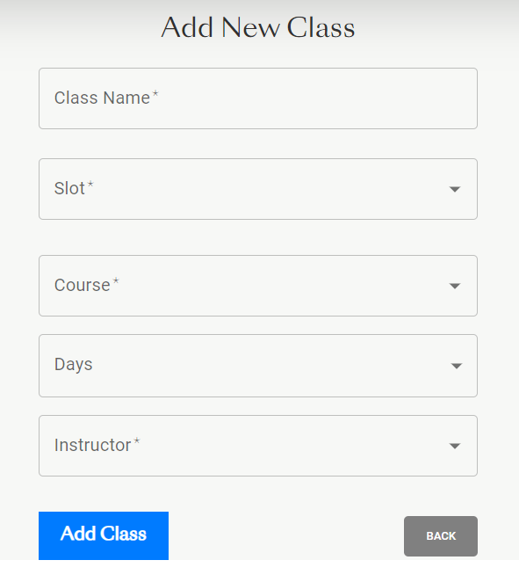

* Function Details: When the user clicks on the “Add” button, this page displays the form for displaying information to add the class.

#### c.3) Update Class

* Function trigger: This function is triggered when the user visits the website or the system to edit the class.
* Function description: The user sees the Manage Class screen.
* Screen layout: simulated screen prototype, the sample below is for the Update Class screen.

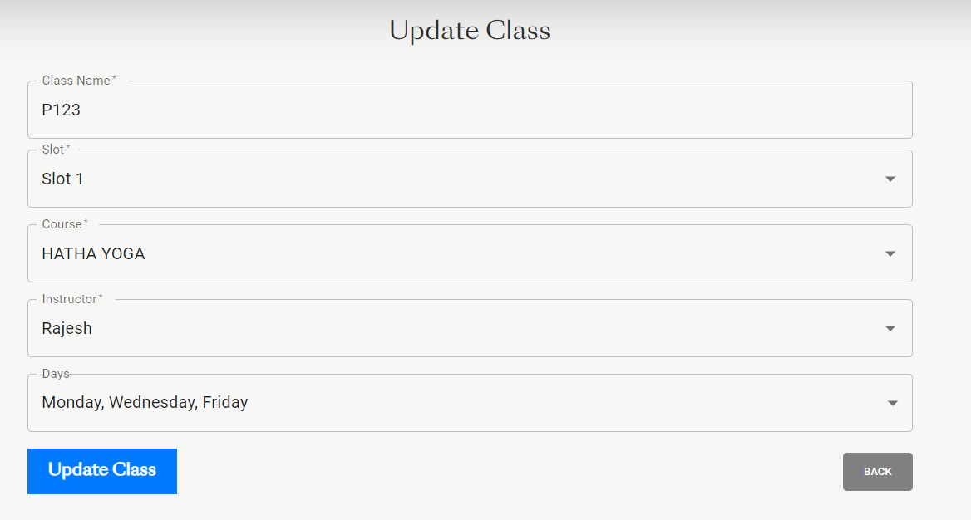

* Function Details: When the user clicks the “Update” button, this page displays the form for editing the class.

#### c.4) Search Class

* Function trigger: This function is triggered when the user visits the website or the system to search the class.
* Function description: The user sees the Manage Class screen.
* Screen layout: simulated screen prototype, the sample below is for the Manage Class screen.

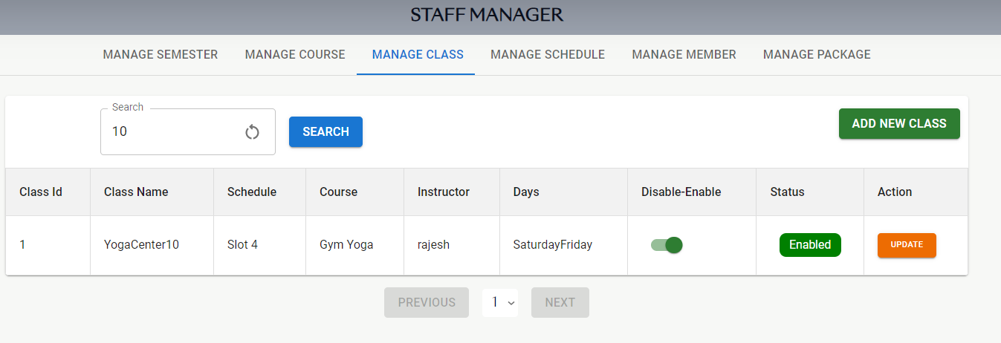

* Function Details: When the user clicks the “Search” button, this page displays the form for searching the class.

### d. Slot Management

#### d.1) View Slot List

* Function trigger: This function is triggered when the user visits the website or the system to view the slot list.
* Function description: The user sees the Manage Slot screen.
* Screen layout: simulated screen prototype, the sample below is for the Manage Slot screen.

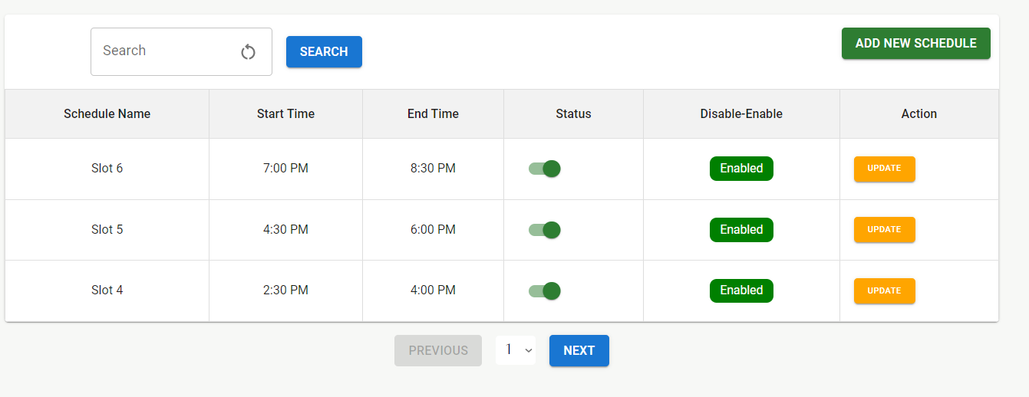

* Function Details: When the user sends the request to get the slot list, this page displays the form for viewing the schedule list.

#### d.2) Add slot

* Function trigger: This function is triggered when the user visits the website or the system to add the slot.
* Function description: The User see the Add Slot screen.
* Screen layout: simulated prototype of the screen, the sample below is for the Add Slot screen.

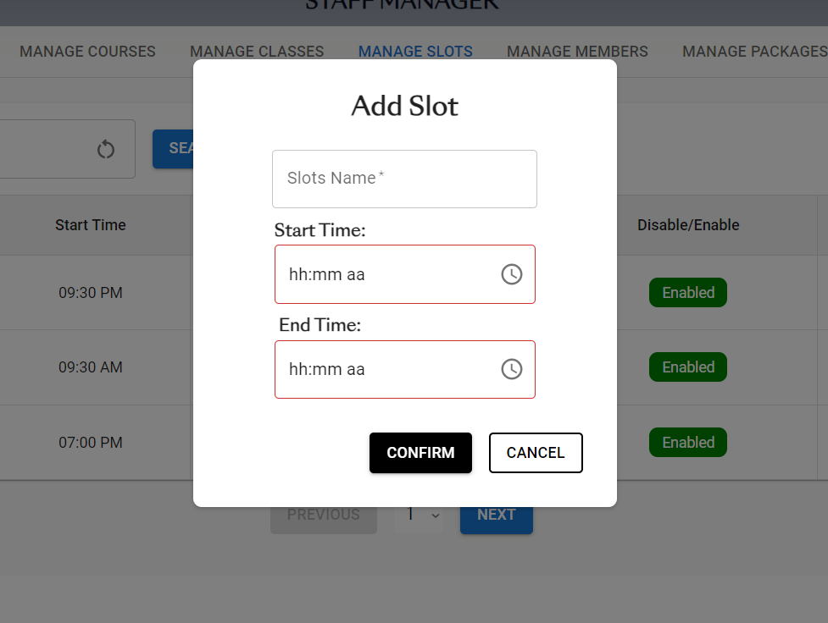

* Function Details: When users click the payment button, this page displays the form for adding the slot.

#### d.3) Edit slot

* Function trigger: This function is triggered when the user visits the website or the system to edit the slot.
* Function description: The User sees the Update Slot screen.
* Screen layout: simulated screen prototype, the sample below is for the Update Slot screen.

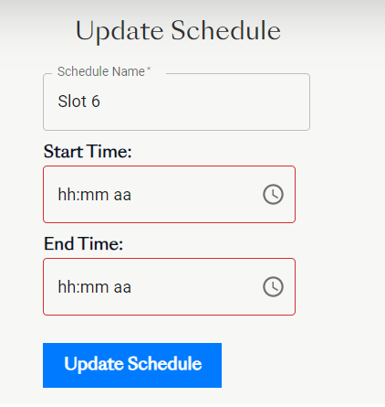

* Function Details: When the user clicks the “Add” button, this page displays the form for updating the slot.

#### d.4) Search slot

* Function trigger: This function is triggered when the user visits the website or the system to search the slot.
* Function description: The User sees the Manage Slot screen.
* Screen layout: simulated screen prototype, the sample below is for the Manage Slot screen.

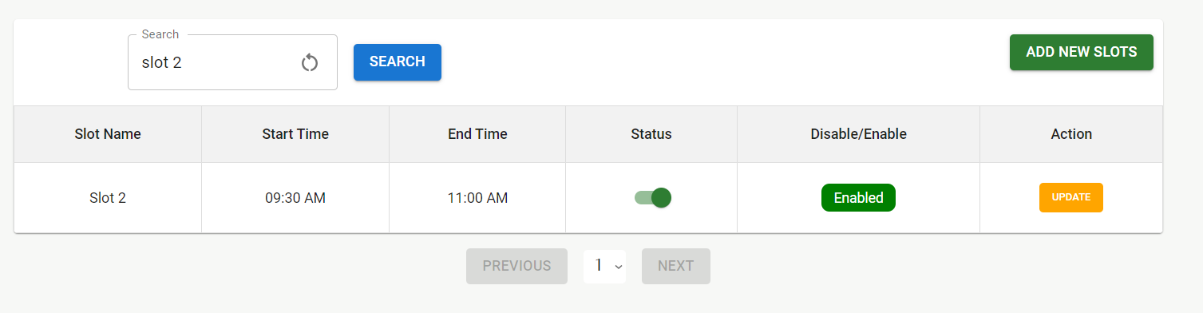

* Function Details: When the user clicks the “Search” button, this page displays the form for searching the slot.

### e. Membership Management

#### e.1) View Member List

* Function trigger: This function is triggered when the user visits the website or the system to view the member list.
* Function description: The user sees the Manage Member screen.
* Screen layout: simulated screen prototype, the sample below is for the Manage Member screen.

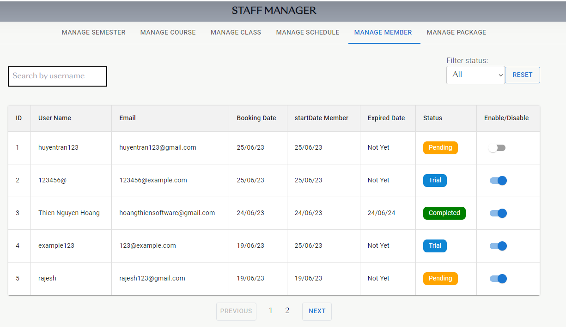

* Function Details: When the user sends the request to see the member list, this page displays the form for viewing the member list.

#### e.2) Update the member status

* Function trigger: This function is triggered when the user visits the website or the system to update the member status.
* Function description: The user sees the Manage Member screen.
* Screen layout: simulated screen prototype, the sample below is for the Manage Member screen.



* Function Details: When the user clicks on the “Update” button, this page displays the form for updating the member status.

#### e.3) Search Member

* Function trigger: This function is triggered when the user visits the website or the system to search the member.
* Function description: the user sees the Manage Member screen.
* Screen layout: simulated screen prototype, the sample below is for the Manage Member screen.

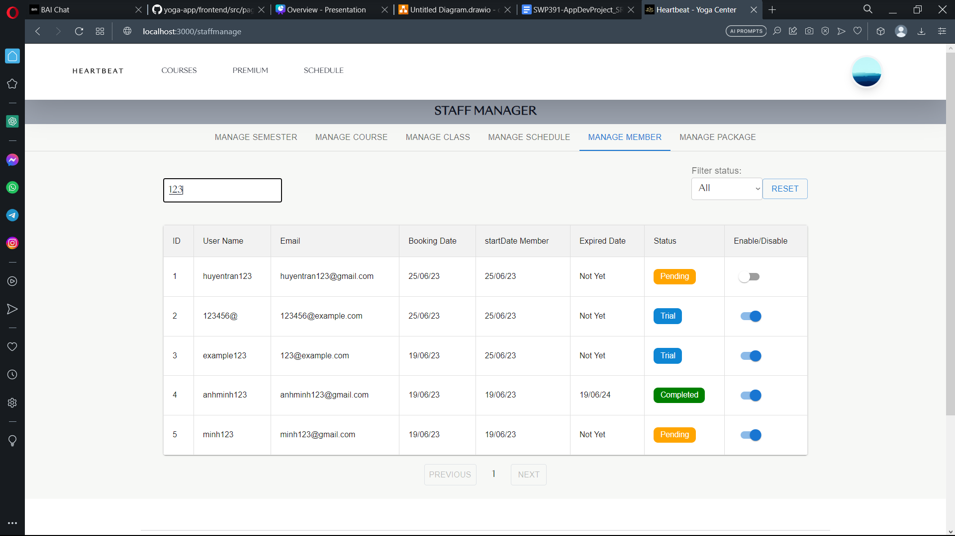

* Function Details: When the user clicks the “Search” button, this page displays the form for searching for the member.

#### e.4) Filter Member

* Function trigger: This function is triggered when the user visits the website or the system to filter the schedule.
* Function description: The user sees the Manage Member screen.
* Screen layout: simulated screen prototype, the sample below is for the Manage Class screen.

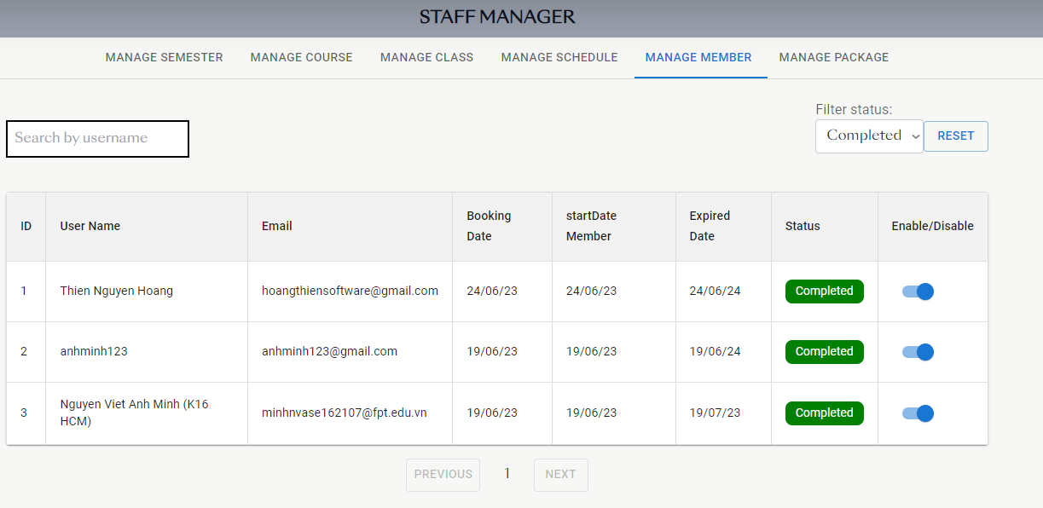

* Function Details: When users click the payment button, this page displays the form for filtering the schedule list.

### f. Package Management

#### f.1) View Package List

* Function trigger: This function is triggered when the user visits the website or the system to view the package list.
* Function description: The user sees the Manage Package screen.
* Screen layout: simulated screen prototype, the sample below is for the Manage Package screen.

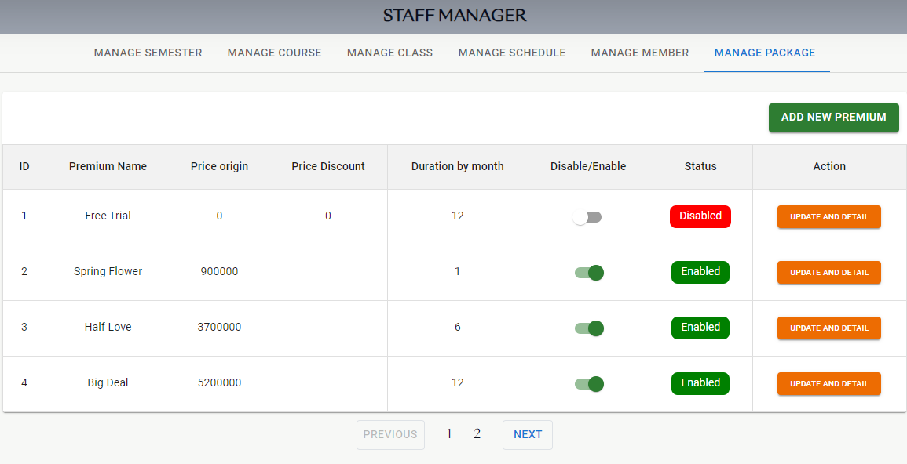

* Function Details: When the user sends the request to get the package list, this page displays the form for viewing the package list.

#### f.2) Add Package

* Function trigger: This function is triggered when the user visits the website or the system to add the package.
* Function description: The user sees the Add Package screen.
* Screen layout: simulated prototype of the screen, the sample below is for the Add Package screen.

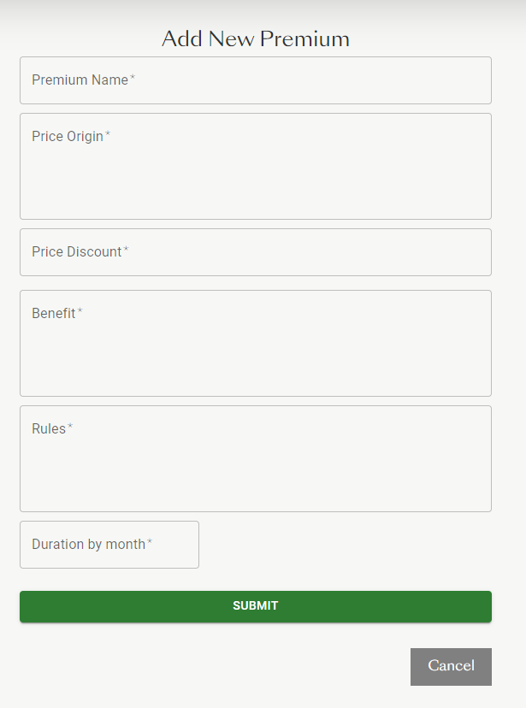

* Function Details: When the user clicks the “Add” button, this page displays the form for adding the package.

#### f.3) Update Package

* Function trigger: This function is triggered when the user visits the website or the system to update the package.
* Function description: The user sees the Update Package screen.
* Screen layout: simulated prototype of the screen, the sample below is for the Update Package screen.

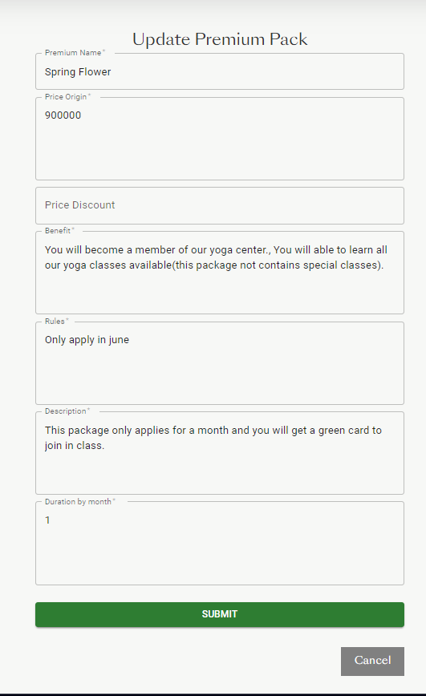

* Function Details: When the user clicks the “Update” button, this page displays the form for updating the package.

#### f.4) Search Package

* Function trigger: This function is triggered when the user visits the website or the system to search the package.
* Function description: The user see the Manage Package screen.
* Screen layout: simulated screen prototype, the sample below is for the Mange Package screen.

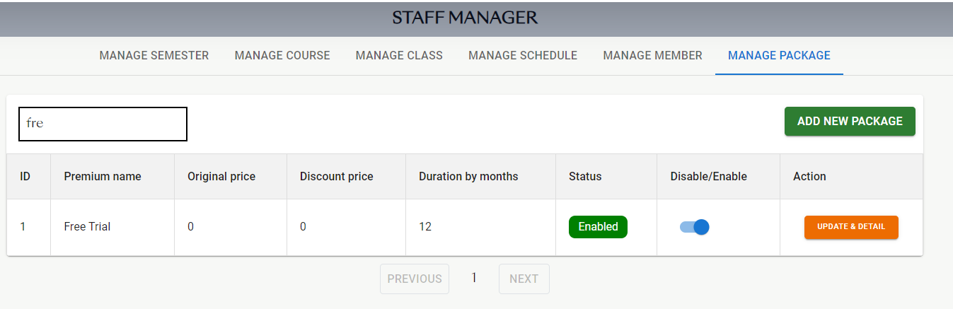

* Function Details: When the user clicks the “Search” button, this page displays the form for searching for the package.

## 5. Admin Feature

### a. Account Management

#### a.1) View Account List

* Function trigger: This function is triggered when the user visits the website or the system to view the account list.
* Function description: The user sees the Manage Account screen.
* Screen layout: simulated screen prototype, the sample below is for the Manage Account screen.

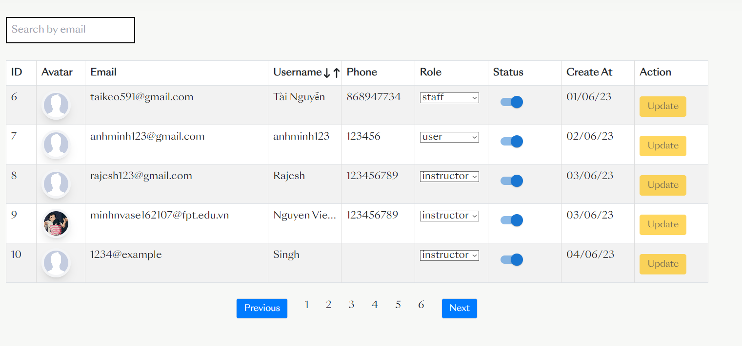

* Function Details: When the user sends the request to get the account list, this page displays the form for viewing the account list.

#### a.2) Search Account

* Function trigger: This function is triggered when the user visits the website or the system to search the account.
* Function description: The user sees the Manage Account screen.
* Screen layout: simulated screen prototype, the sample below is for the Manage Account screen.

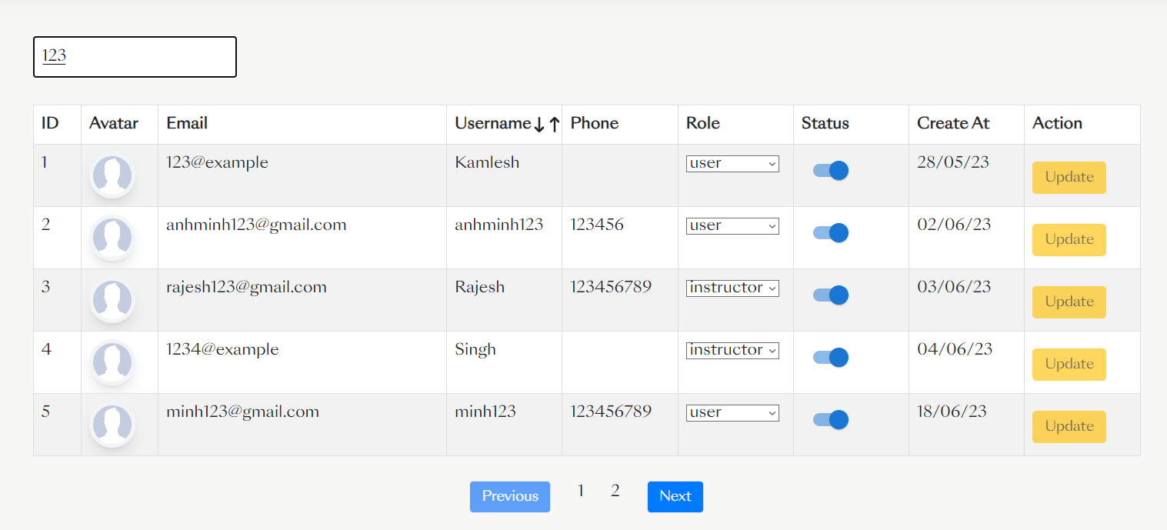

* Function Details: When the users click the “Search” button, this page displays the form for searching for the account.

#### a.3) Update Account Status

* Function trigger: This function is triggered when the user visits the website or the system to update the account status.
* Function description: The user sees the Manage Account screen.
* Screen layout: simulated screen prototype, the sample below is for the Manage Account screen.

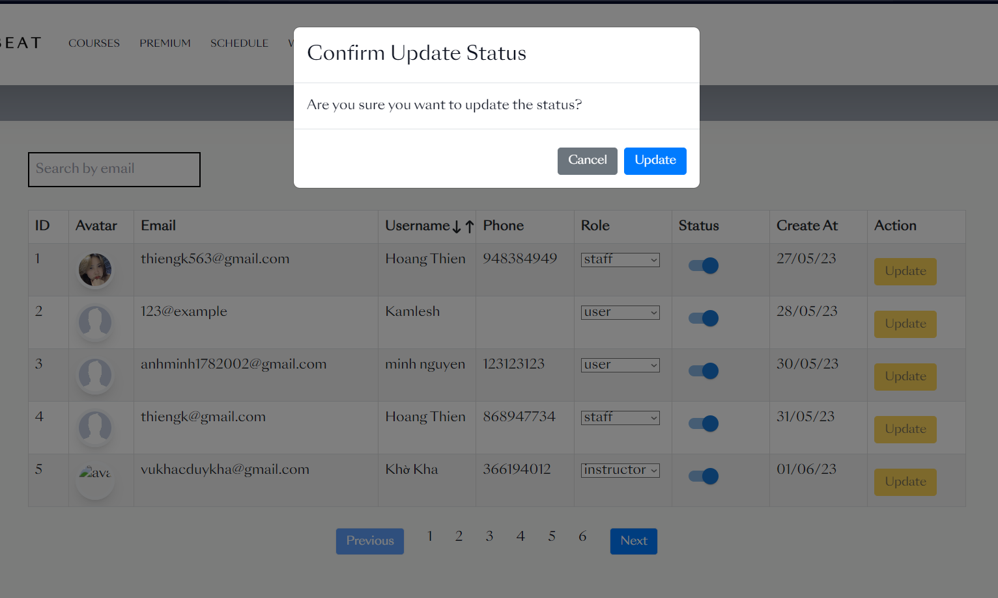

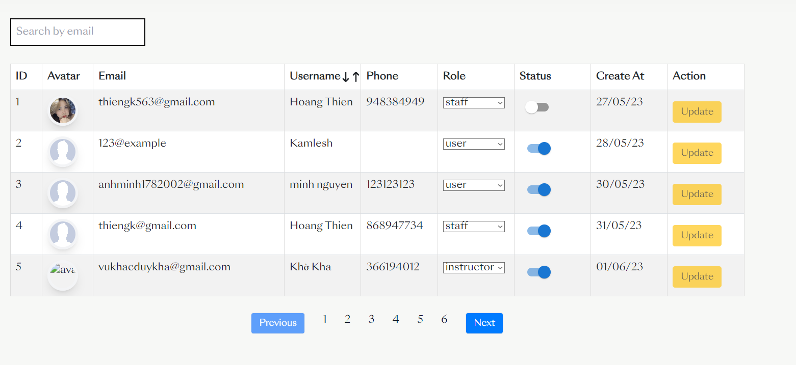

* Function Details: When the users click the “Update” button, this page displays the form for updating the status of the account.

#### a.4) Update Account Role

* Function trigger: This function is triggered when the user visits the website or the system to update the account role.
* Function description: The user sees the Manage Account screen.
* Screen layout: simulated screen prototype, the sample below is for the Manage Account screen.

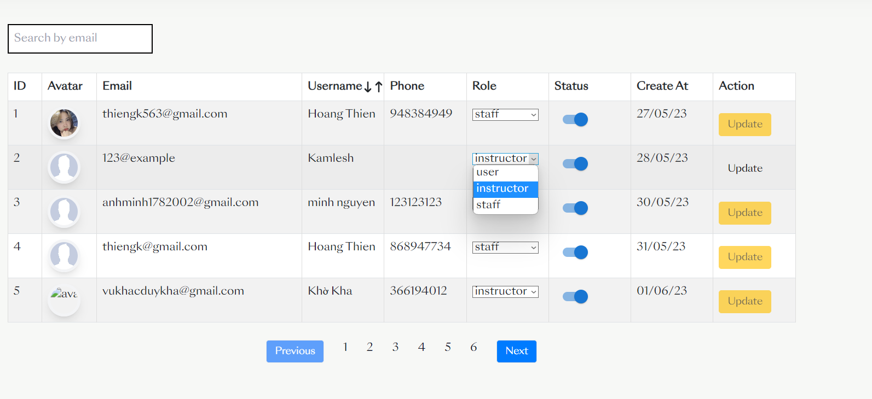

* Function Details: When the users click the “Update” button, this page displays the form for updating the role of the account.

### b. Admin Dashboard

* Function trigger: This function is triggered when the user visits the website or the system to see the information of the application
* Function description: The user sees the Admin Dashboard screen.
* Screen layout: simulated screen prototype, the sample below is for the Admin Dashboard screen.

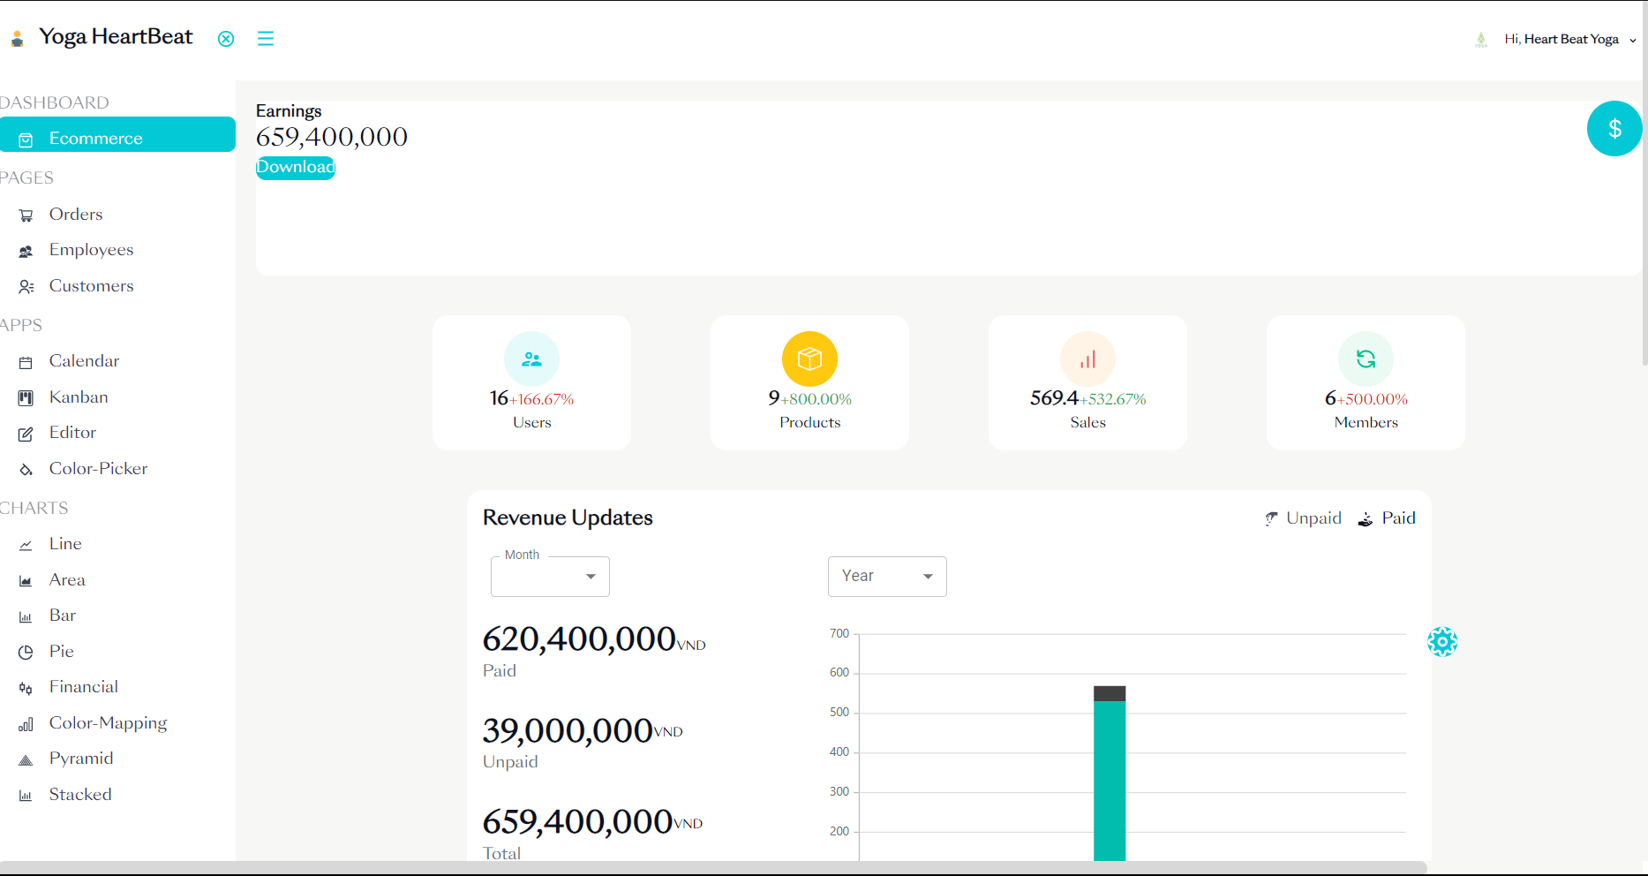

* Function Details: When the user sends the request to view the dashboard, this page displays the form to see the information about the application